## **21. Spanning Tree Protocol (STP): Part 2**

### **STP States**

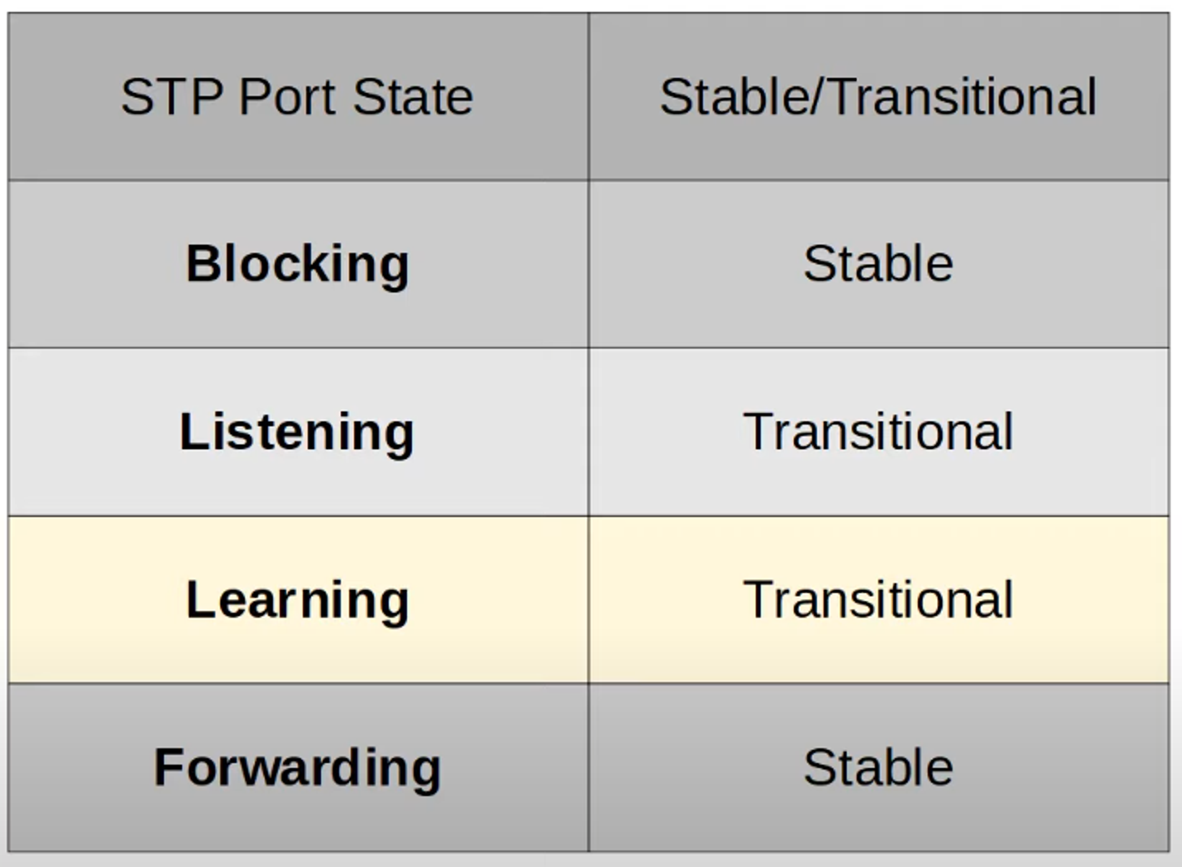

* **Root/Designated Ports** remain **stable** in a **forwarding** state.
* **Non-Designated Ports** remain **stable** in a **blocking** state.
* **Listening** and **Learning** are **transitional states** passed through when:
  + An interface is activated, or
  + A **blocking port** transitions to a **forwarding** state due to network topology changes.

#### **1) Blocking (Stable)**

* **Non-Designated Ports** are in a **blocking** state.
* Interfaces in a **blocking** state:
  + Prevent loops by being effectively disabled.
  + Do **not** send/receive regular network traffic or STP BPDUs.
  + Do **not** learn MAC addresses.

#### **2) Listening (Transitional)**

* After the **blocking** state, interfaces with the **designated** or **root** role enter the **listening** state.
* **Key Points**:
  + Only **designated** or **root ports** enter this state.
  + The state lasts **15 seconds** (default) as defined by the **forward delay timer**.
  + Interfaces:
    - Do **not** send/receive regular network traffic.
    - Only forward/receive STP BPDUs.
    - Do **not** learn MAC addresses.

#### **3) Learning (Transitional)**

* After the **listening** state, a **designated** or **root port** enters the **learning** state.
* **Key Points**:
  + Lasts **15 seconds** (default, same timer as listening).
  + Interfaces:
    - Do **not** send/receive regular traffic.
    - Only send/receive STP BPDUs.
    - **Learn MAC addresses** from incoming traffic.

#### **4) Forwarding (Stable)**

* **Root** and **designated ports** are in the **forwarding** state.
* **Key Points**:
  + Ports operate as normal, sending/receiving both regular traffic and STP BPDUs.
  + **Learn MAC addresses** as traffic flows.\

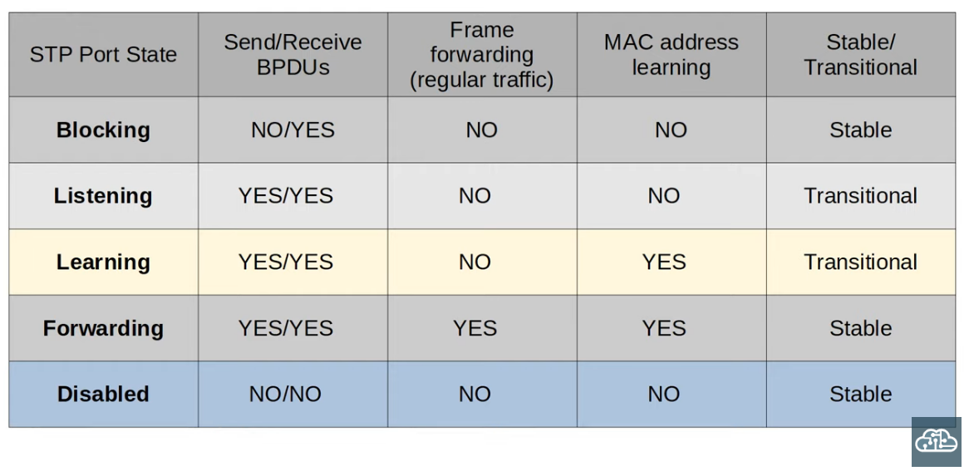

### 

### **STP Timers**

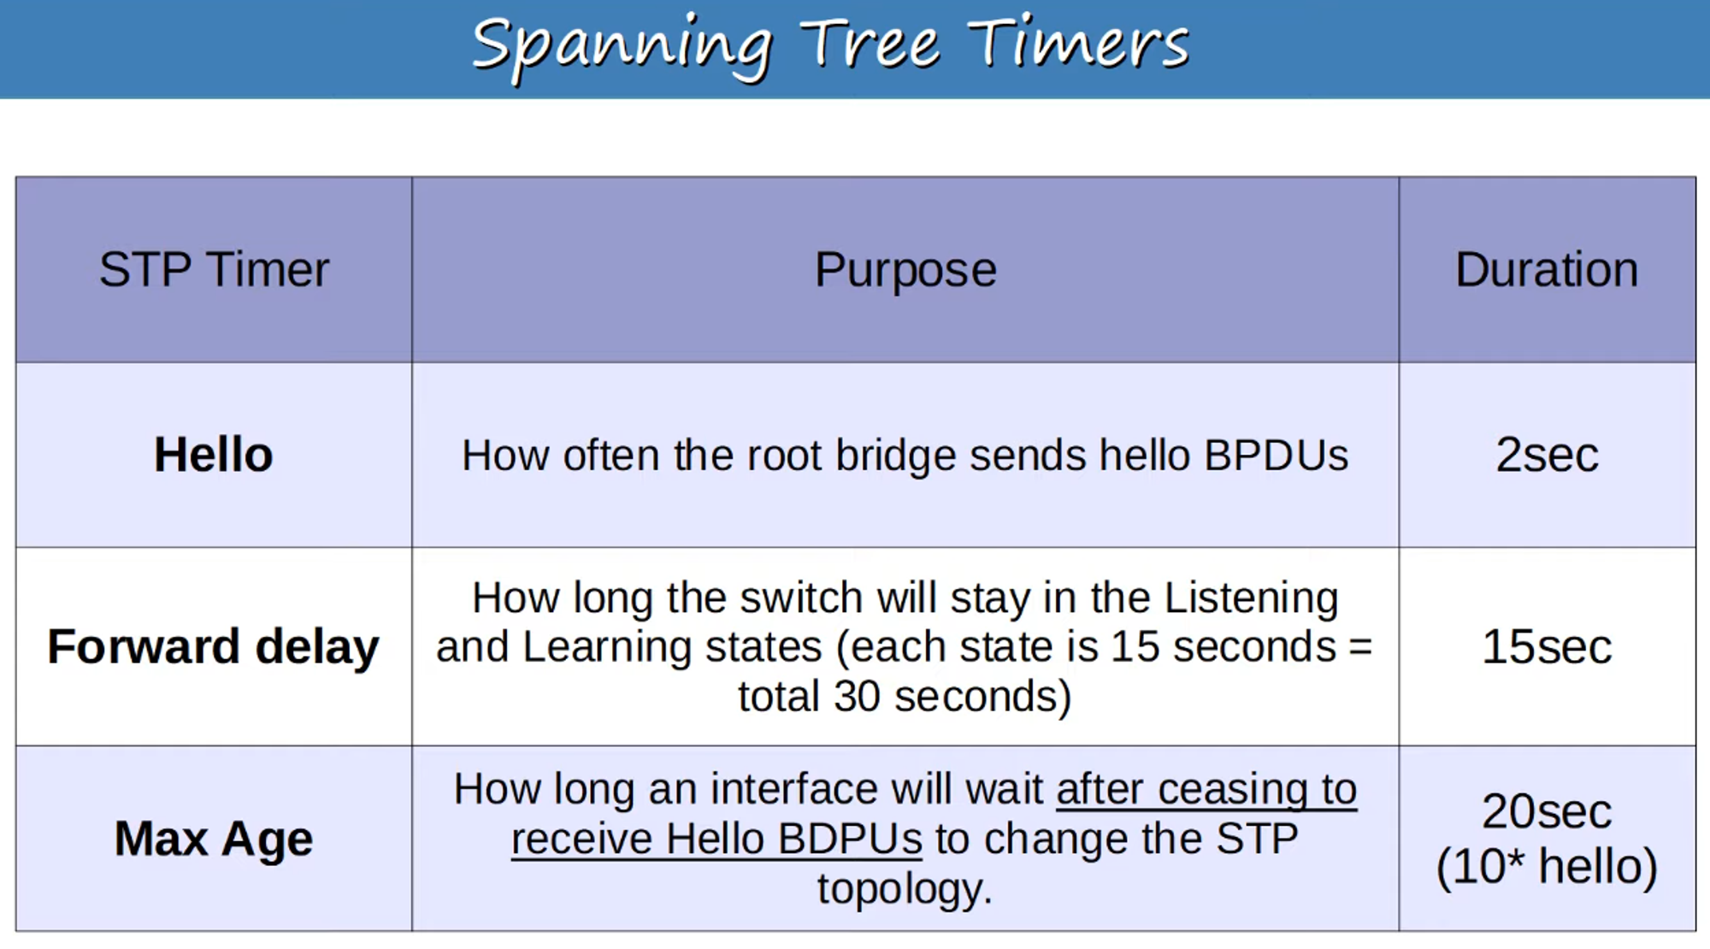

💡 **Switches do not forward BPDUs out of root or non-designated ports**—only **designated ports**.

#### **Max Age Timer**

* If another BPDU is received **before the timer reaches 0**, the timer resets to **20 seconds**, and no changes occur.
* If no BPDU is received:
  + The timer counts down to **0**, and the switch re-evaluates:
    - Root bridge, root port, designated ports, and non-designated ports.
  + A **non-designated port** selected as root or designated will transition:
    - **Blocking → Listening (15s) → Learning (15s) → Forwarding**.
  + Total transition time: **50 seconds**.

💡 **Note**:

* A **forwarding interface** can directly move to **blocking**.
* A **blocking interface** cannot directly move to **forwarding**—it must transition through **listening** and **learning**.

### 

### 

### 

### **STP BPDU (Bridge Protocol Data Unit)**

**Ethernet Header of a BPDU** 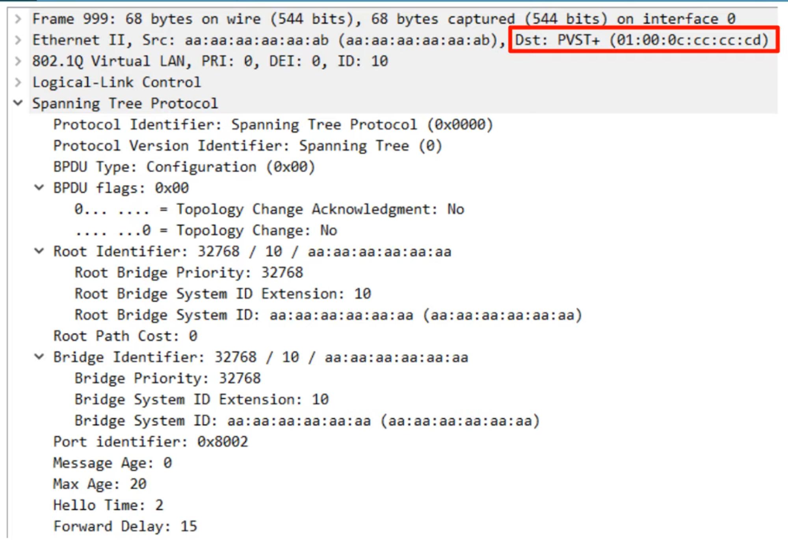

* **PVST+** uses MAC address: 01:00:0c:cc:cc:cd
  + **PVST**: Only ISL trunk encapsulation.
  + **PVST+**: Supports 802.1Q.
* **Regular STP** uses MAC address: 0180.c200.0000.
* **Root Bridge Timers** determine all STP timers for the network.

### **STP Optional Features**

#### **PortFast**

* **Enables ports** connected to end hosts to move **immediately to the forwarding state**, bypassing transitional states.
* 💡 Use PortFast **only** on ports connected to end hosts to avoid loops.

**Enable PortFast command**: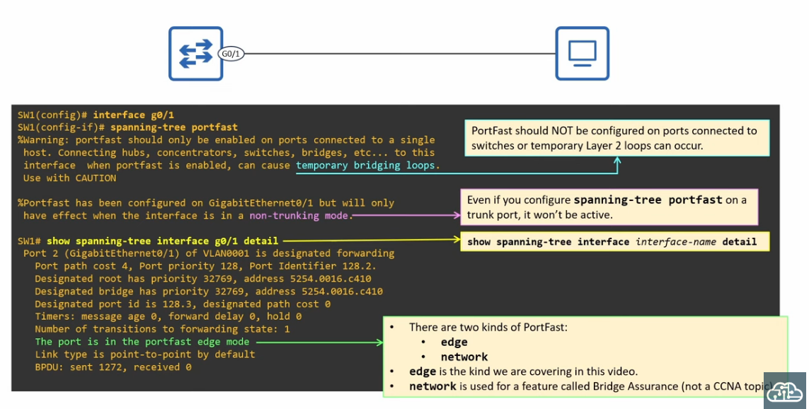

SW1(config)# spanning-tree portfast default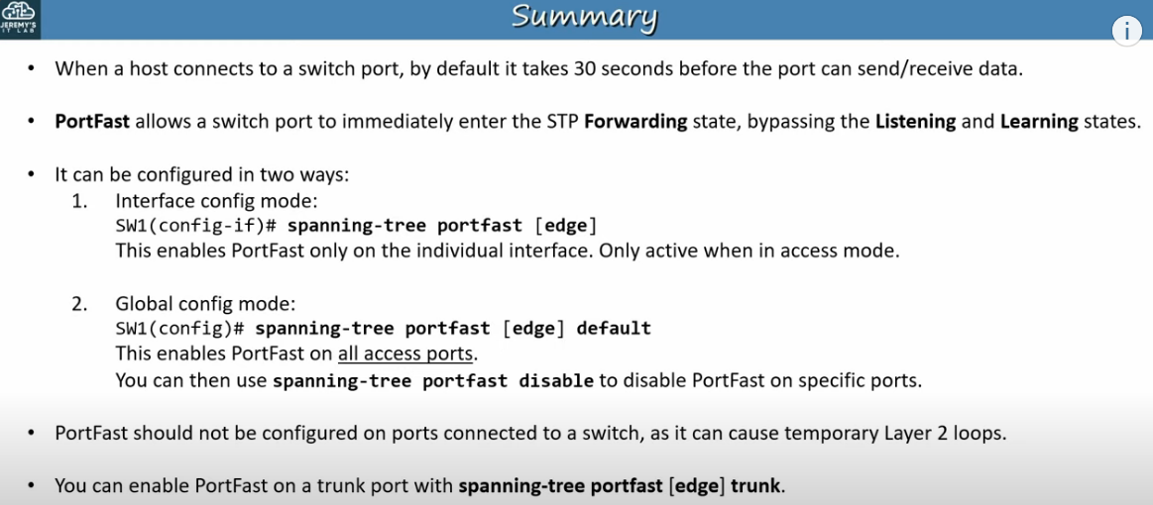

Good to know: (not needed in CCNA)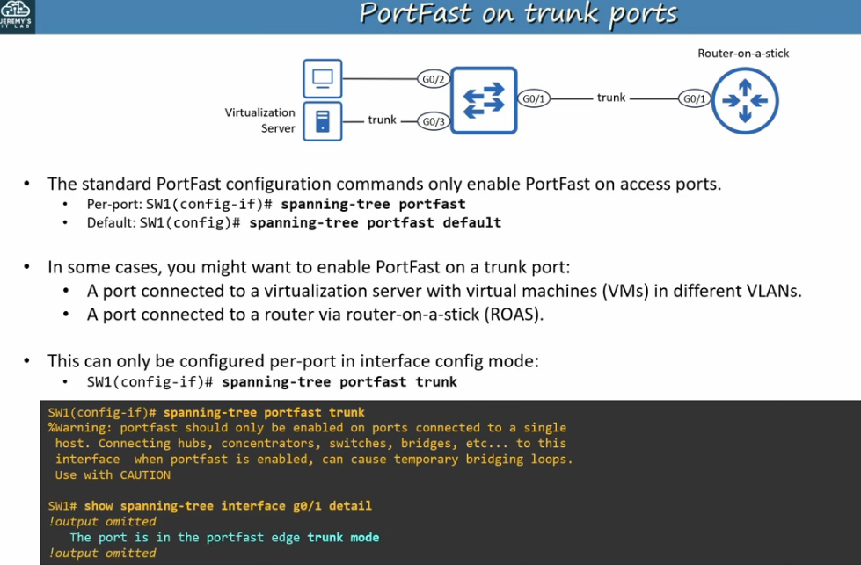

#### 

#### **BPDU Guard**

* Shuts down an interface if it receives a BPDU, preventing loops.

**Enable BPDU Guard command**: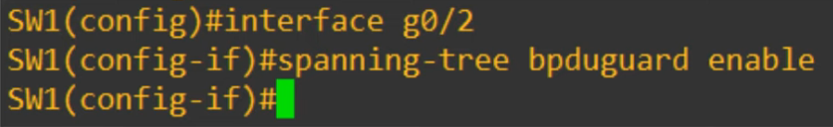

SW1(config)# spanning-tree portfast bpduguard default

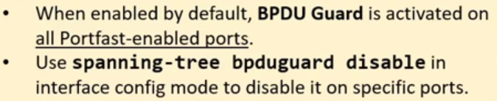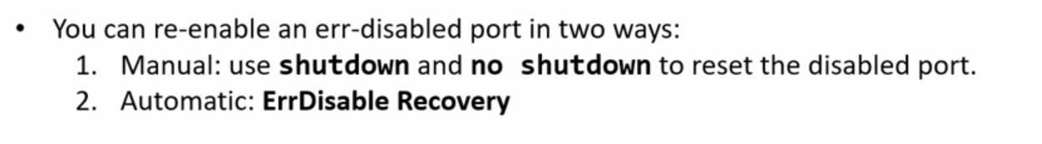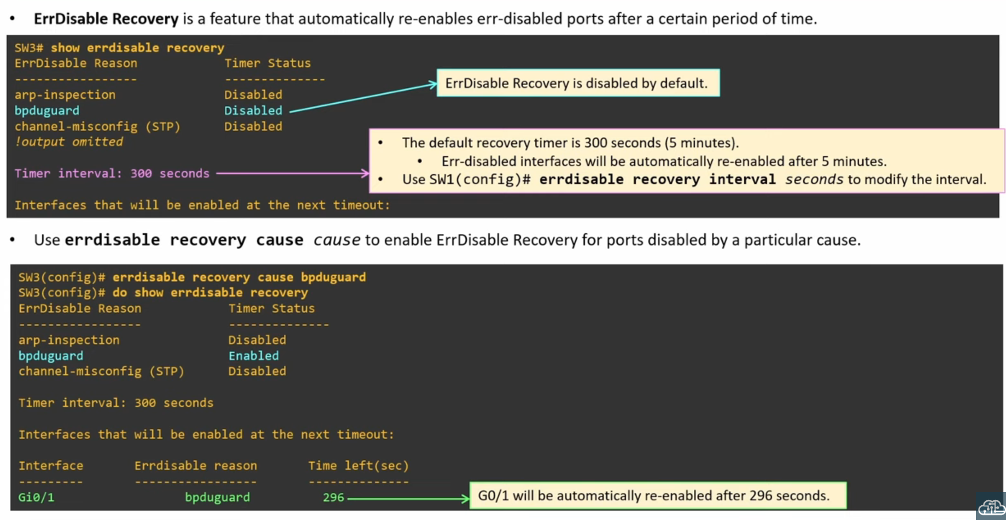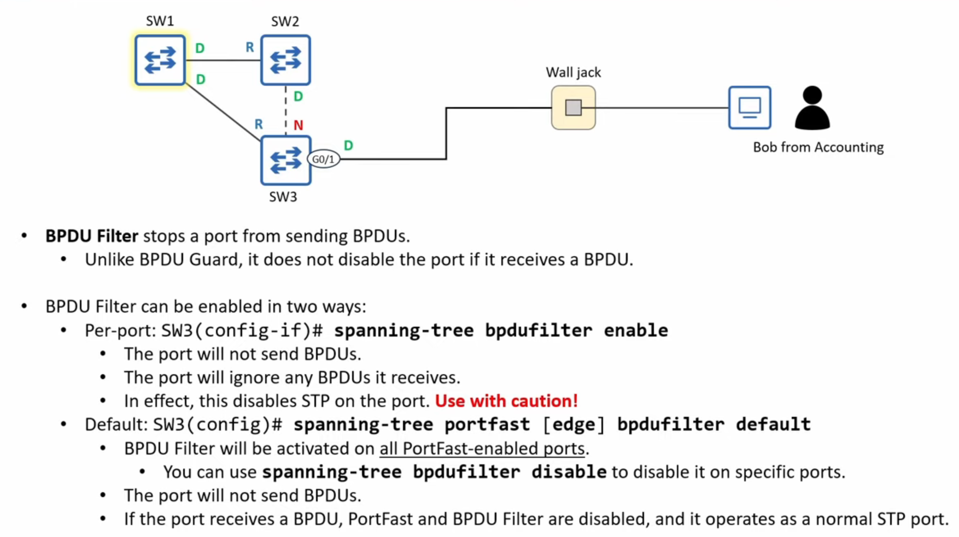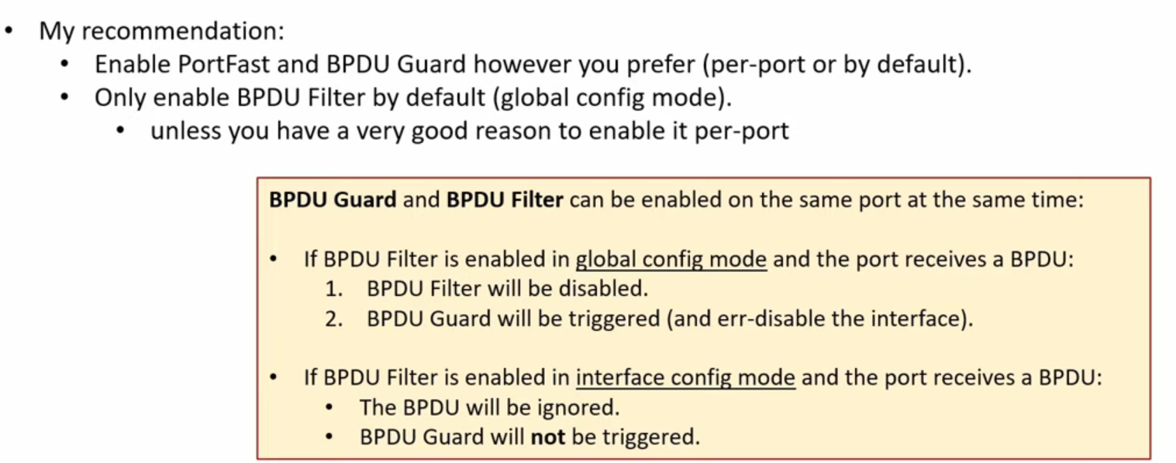

#### 

#### **Root Guard / Loop Guard (Good To Know)**

#### **Root Guard**

* Ensure proper root bridge selection and prevent loops.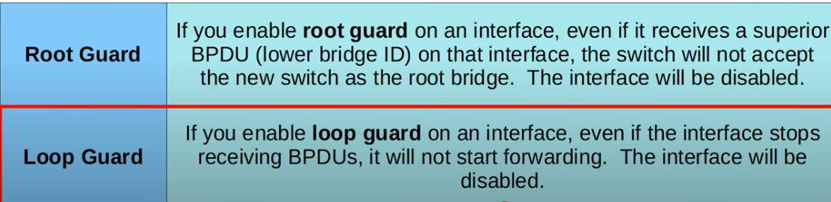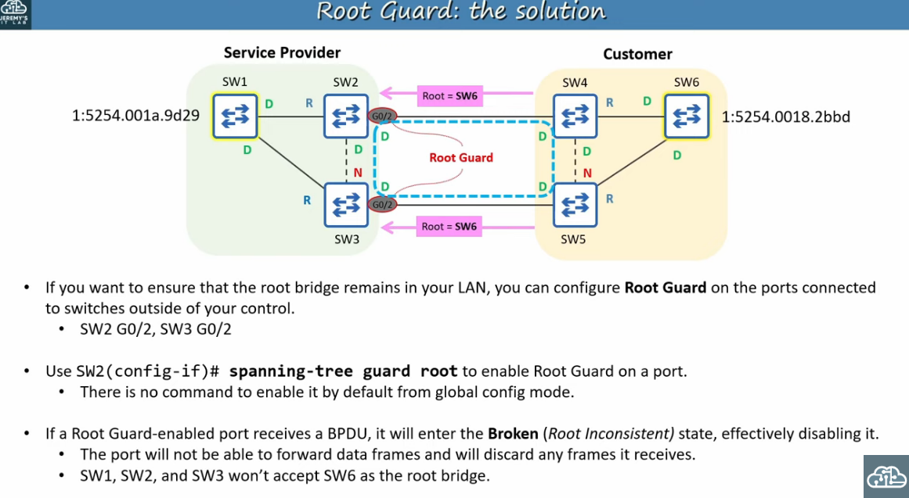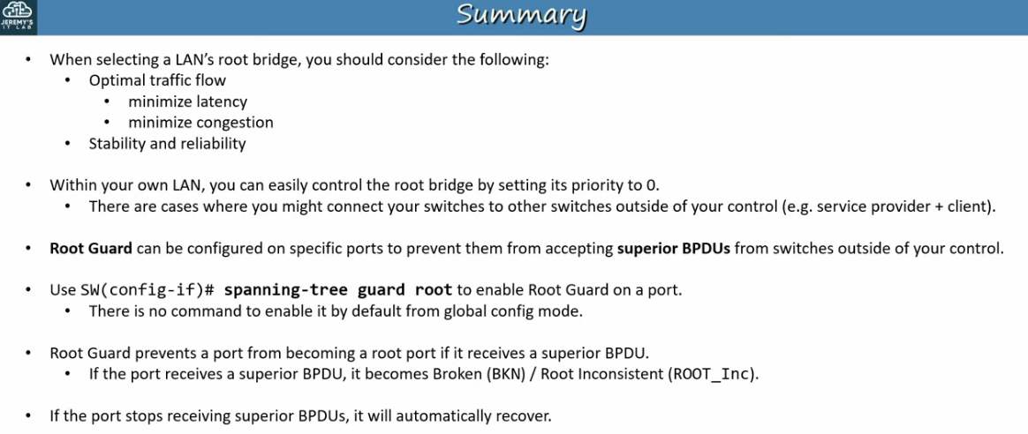

#### **Loop Guard**

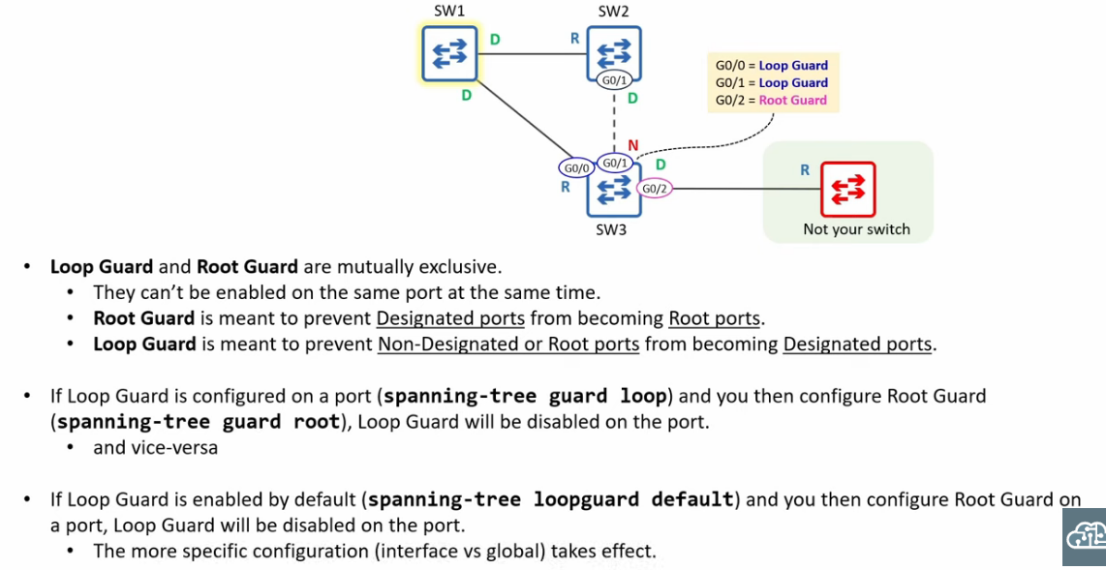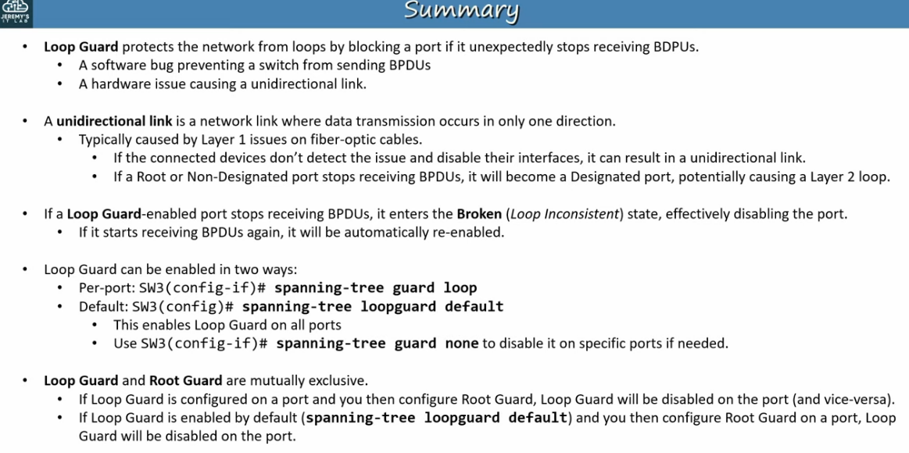

### **STP Configuration**

#### **Configure Spanning-Tree Mode**

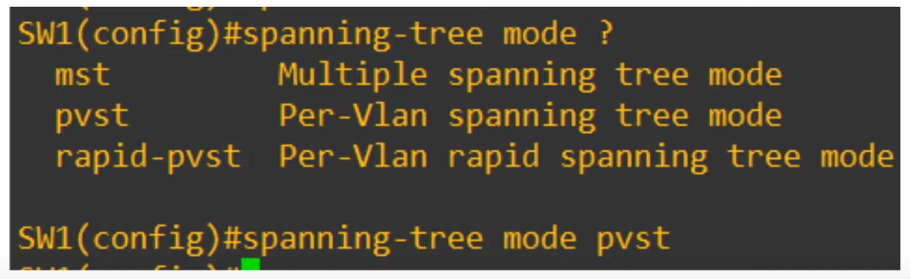

* Modern Cisco switches default to **Rapid-PVST**.

#### **Configure Primary Root Bridge**

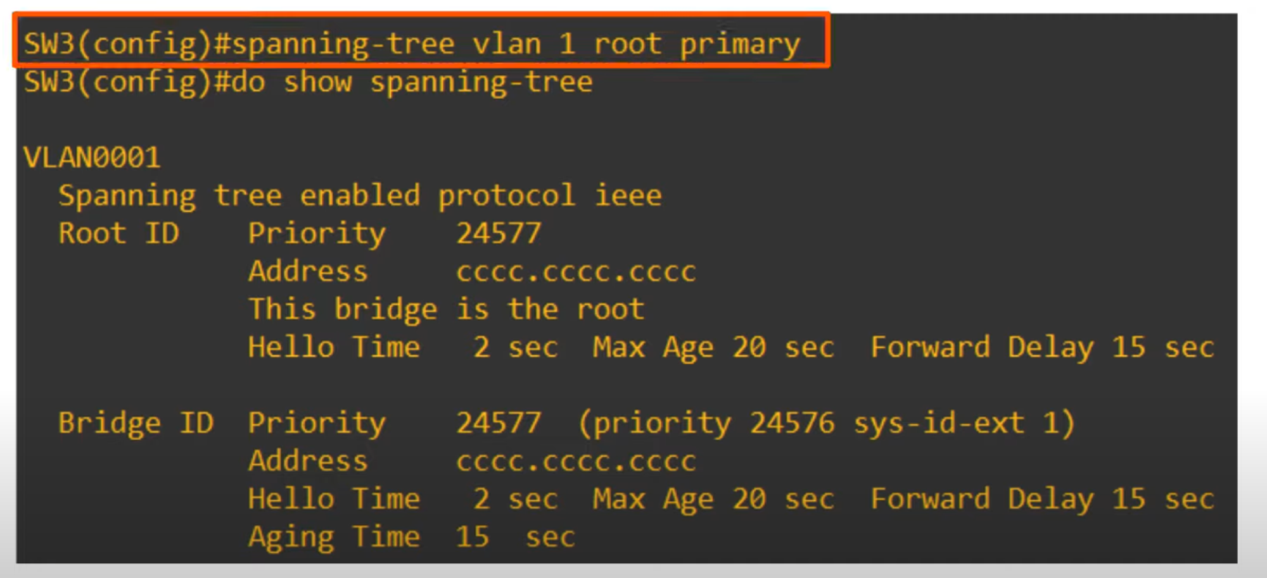

Command:  
# spanning-tree vlan <vlan-number> root primary



#### **Configure Secondary Root Bridge**

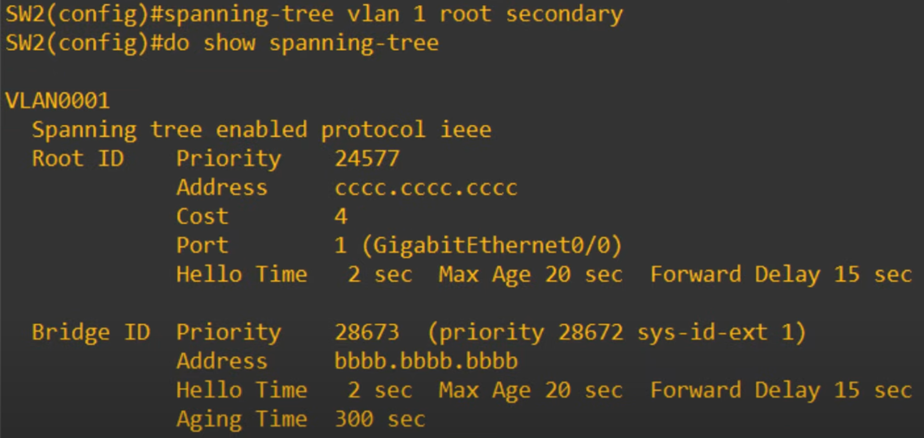

Command:  
 #spanning-tree vlan <vlan-number> root secondary

